* **CloudWatch logs generated by various services such as Lambda, VPC flow logs etc.**

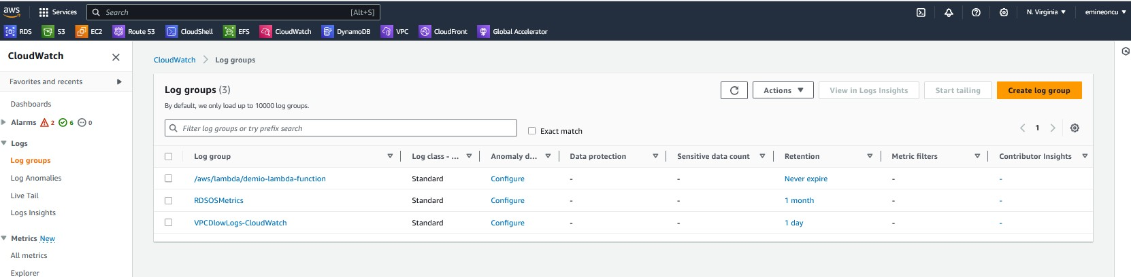

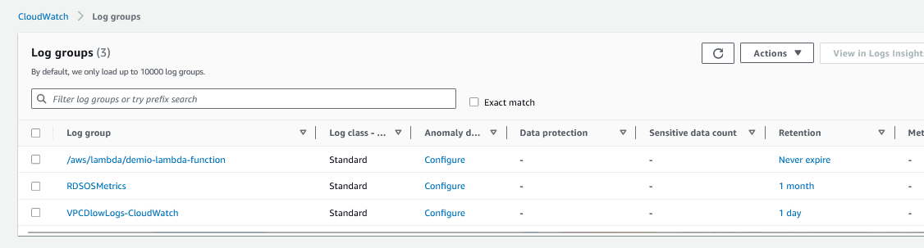

* **CloudWatch Metrics as defined by AWS** [**Link to AWS**](https://docs.aws.amazon.com/AmazonCloudWatch/latest/monitoring/working_with_metrics.html)

**“Metrics are data about the performance of your systems. By default, many services provide free metrics for resources (such as Amazon EC2 instances, Amazon EBS volumes, and Amazon RDS DB instances). You can also enable detailed monitoring for some resources, such as your Amazon EC2 instances, or publish your own application metrics. Amazon CloudWatch can load all the metrics in your account (both AWS resource metrics and application metrics that you provide) for search, graphing, and alarms.”**

* **These metrics are available for the North Virginia region.**

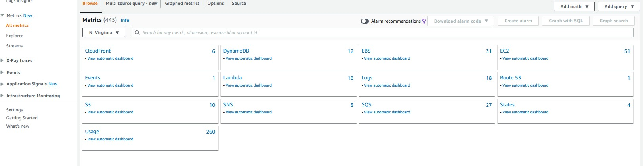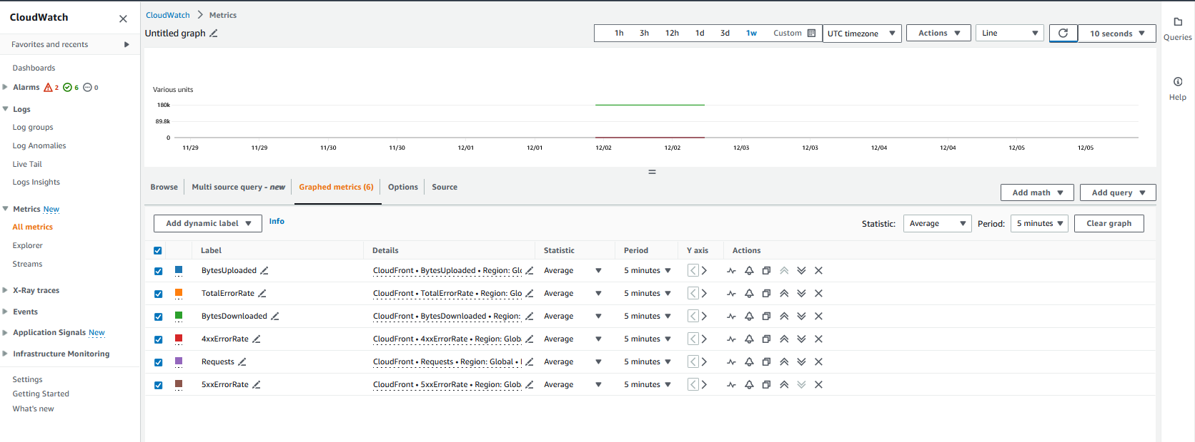

* **These metrics are available for the Ohio region.**

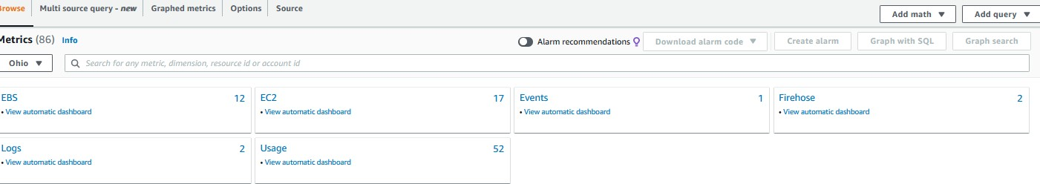

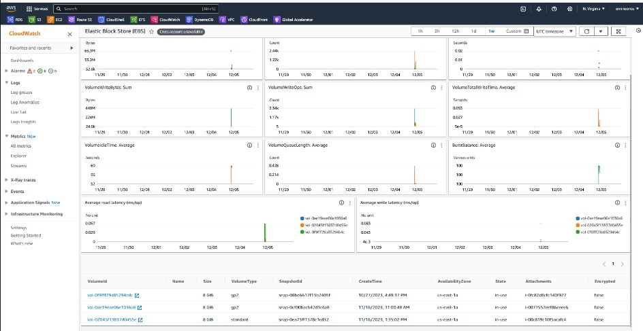

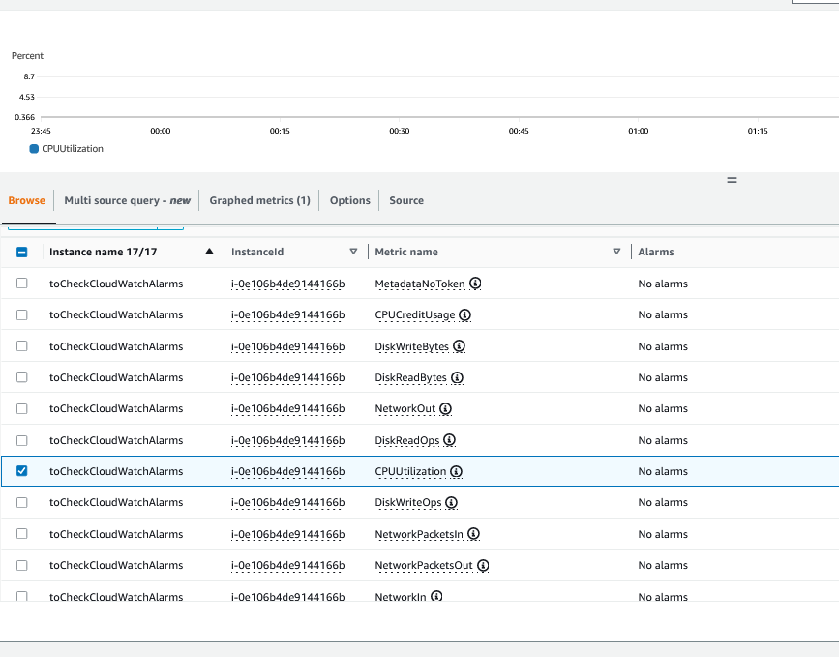

* **Previous alarms that I created.**

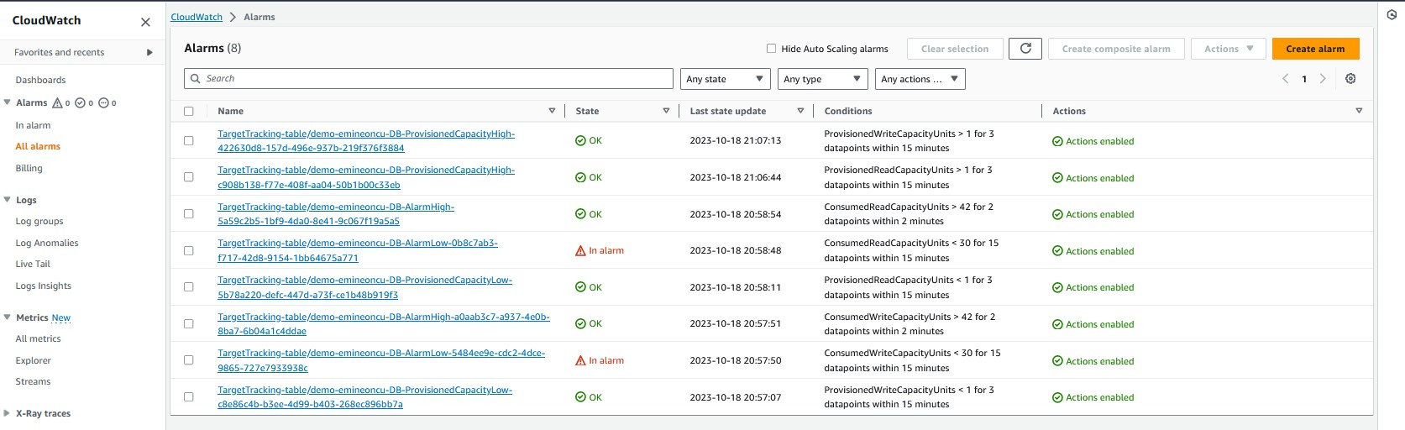

* **Creating an alarm for our EC2 instance**
* **Select the CPU utilization metric if it exceeds 95%**

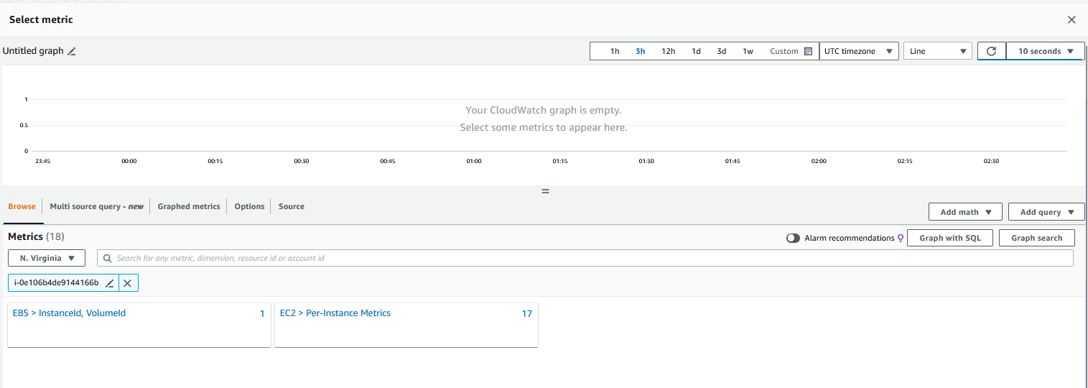

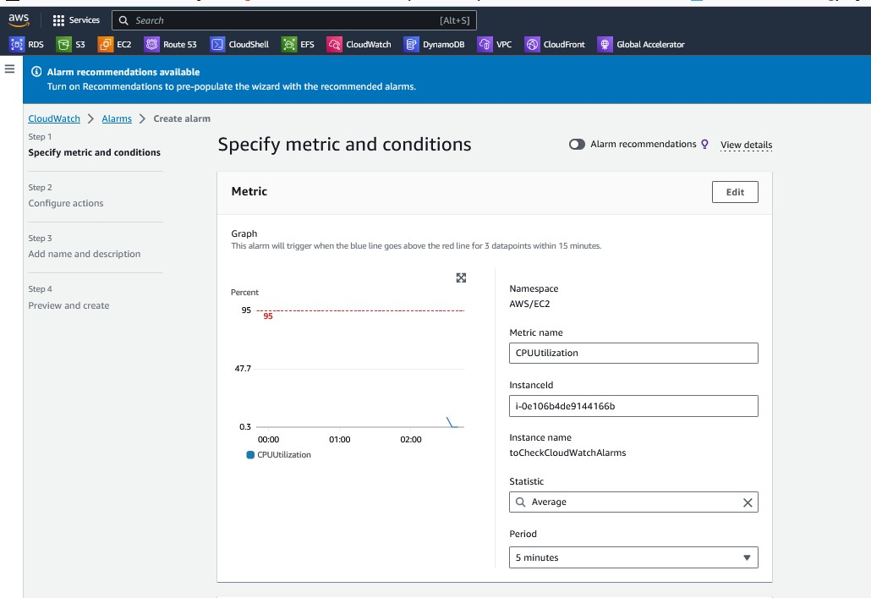

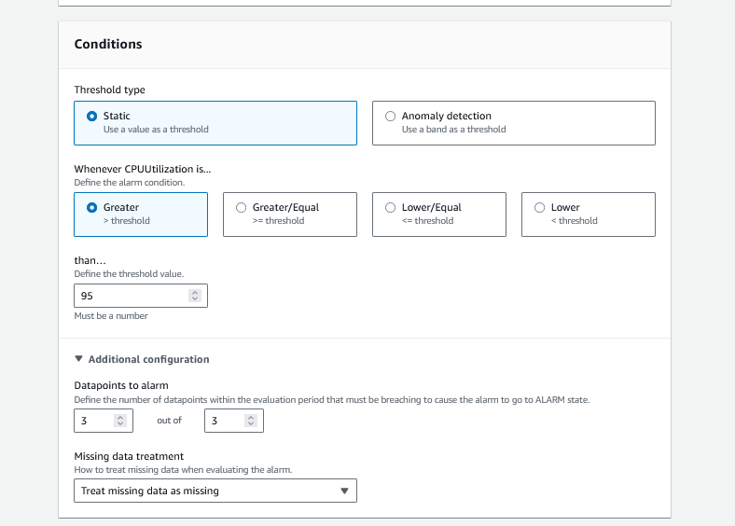

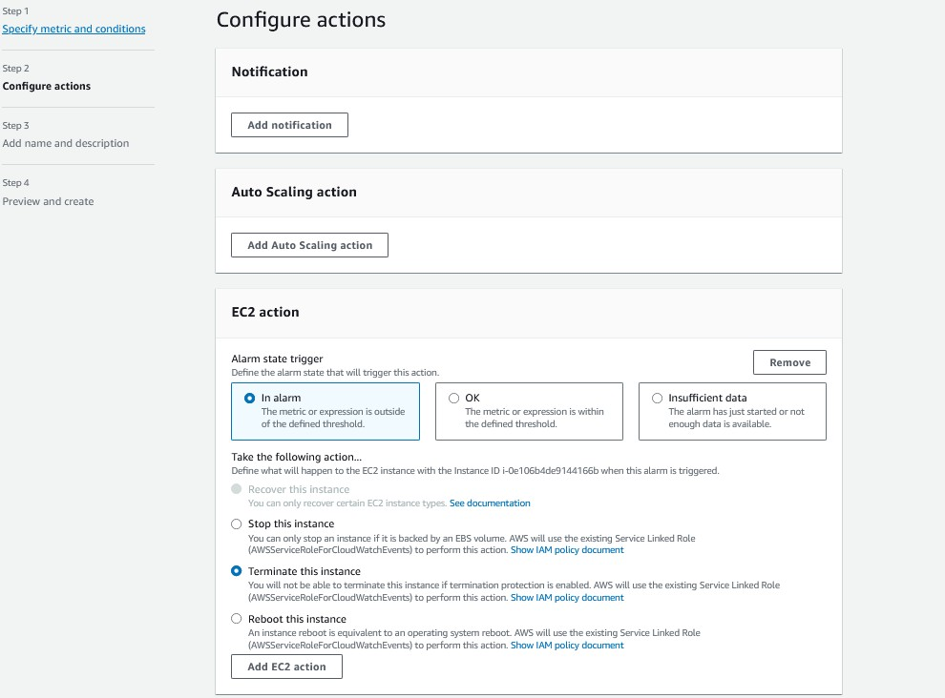

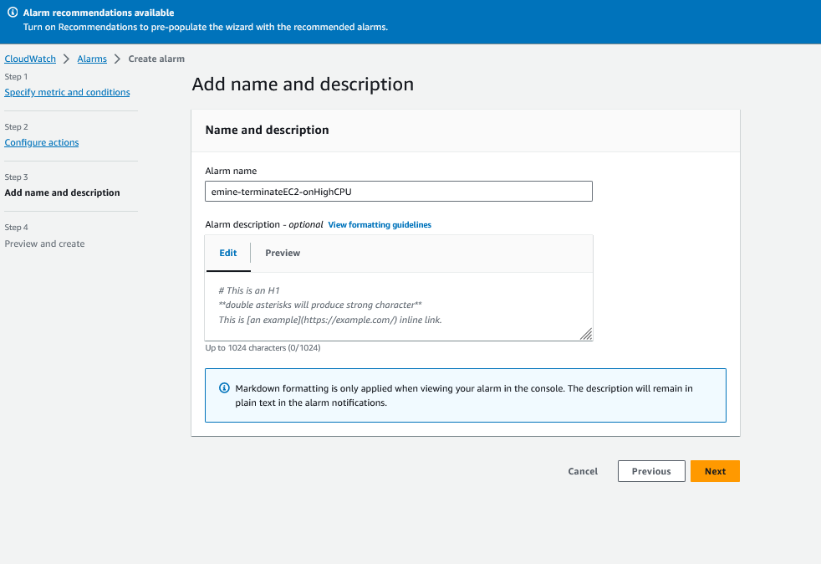

* **We will use the command set-alarm-state to trigger the alarm instead of waiting until the CPU reaches 95%.**
* **Forcefully triggered using the following command:**

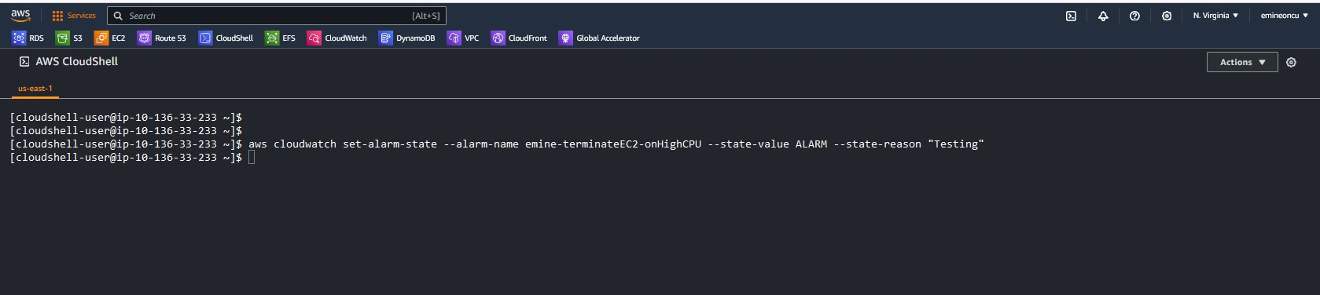

* **aws cloudwatch set-alarm-state --alarm-name emine-terminateEC2-onHighCPU --state-value ALARM --state-reason "Testing."**
* **Instance terminated.**

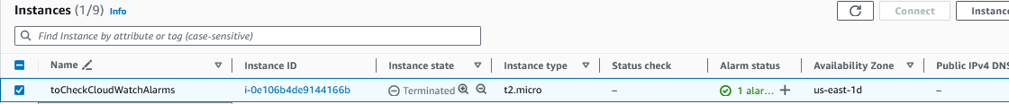

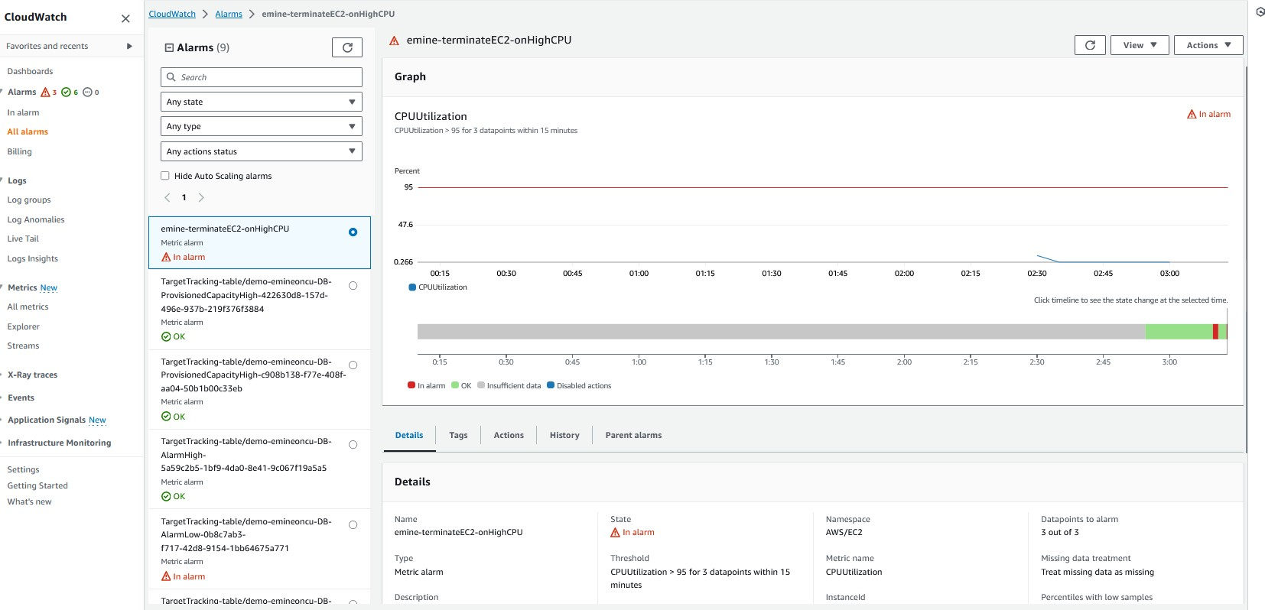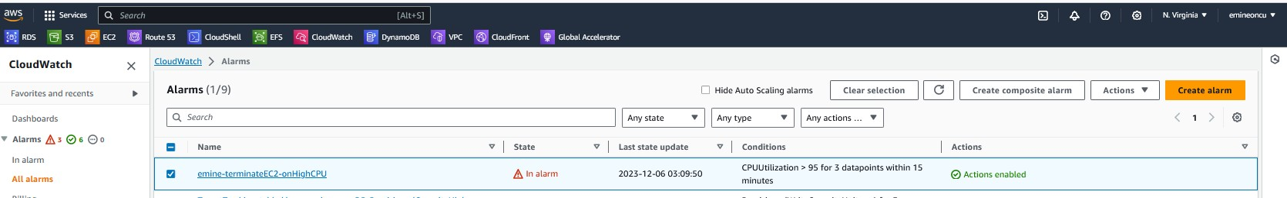

* **Create an Event Bus**

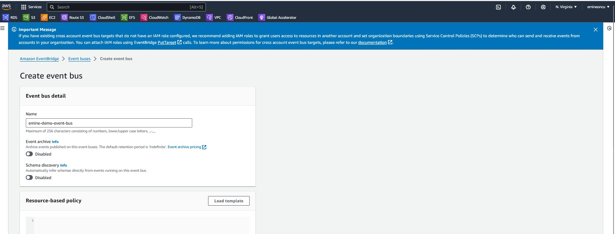

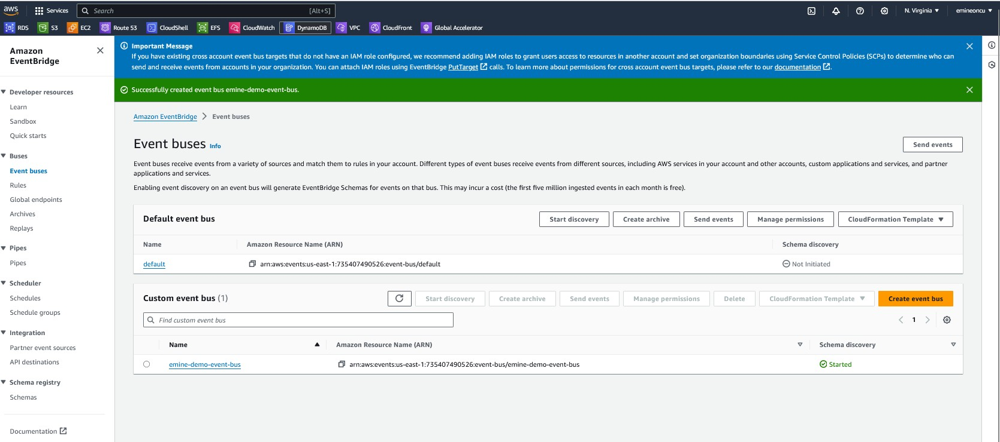

* **Created Event Bus**



* 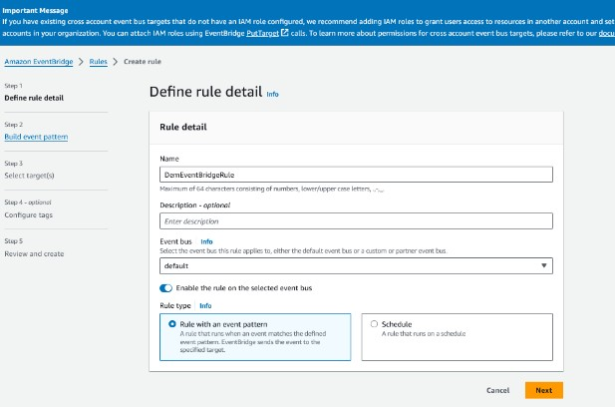**Create Event rule.**

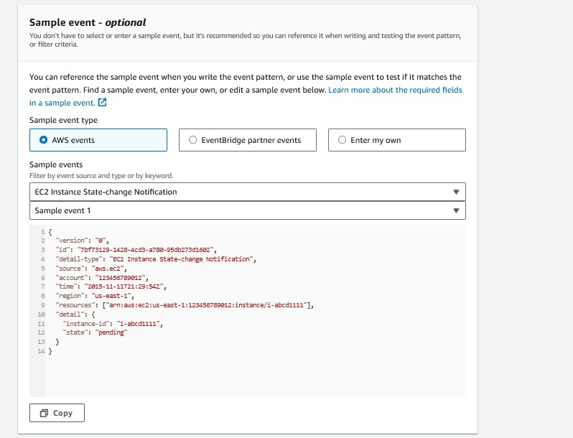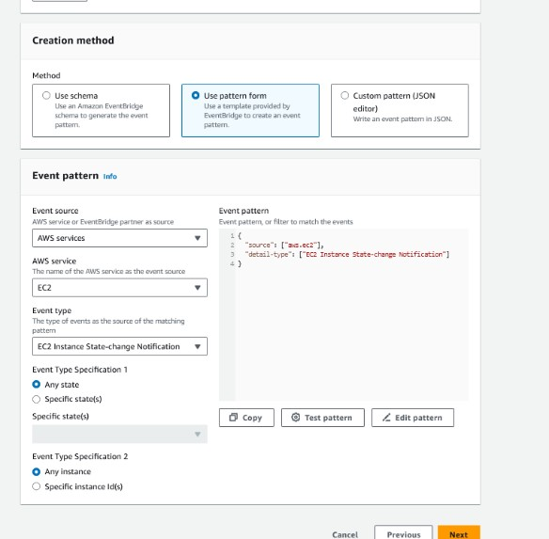

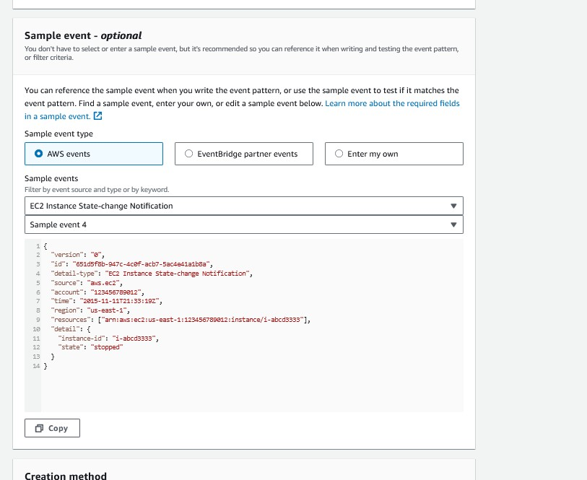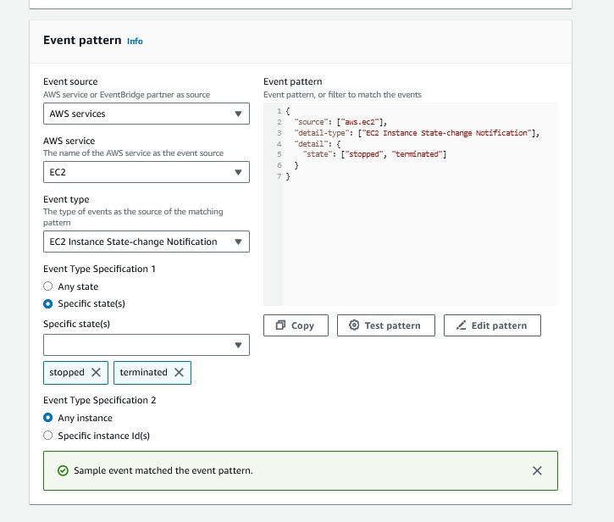

* + 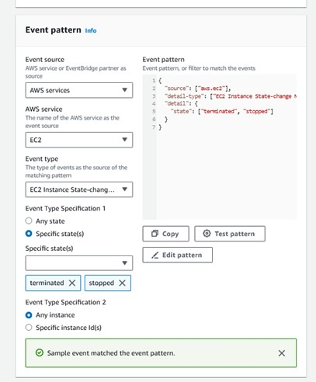**Sending the notification of an event (For example, EC2 instance is stopped or terminated) to an SNS topic, which will be subscribed using email.**

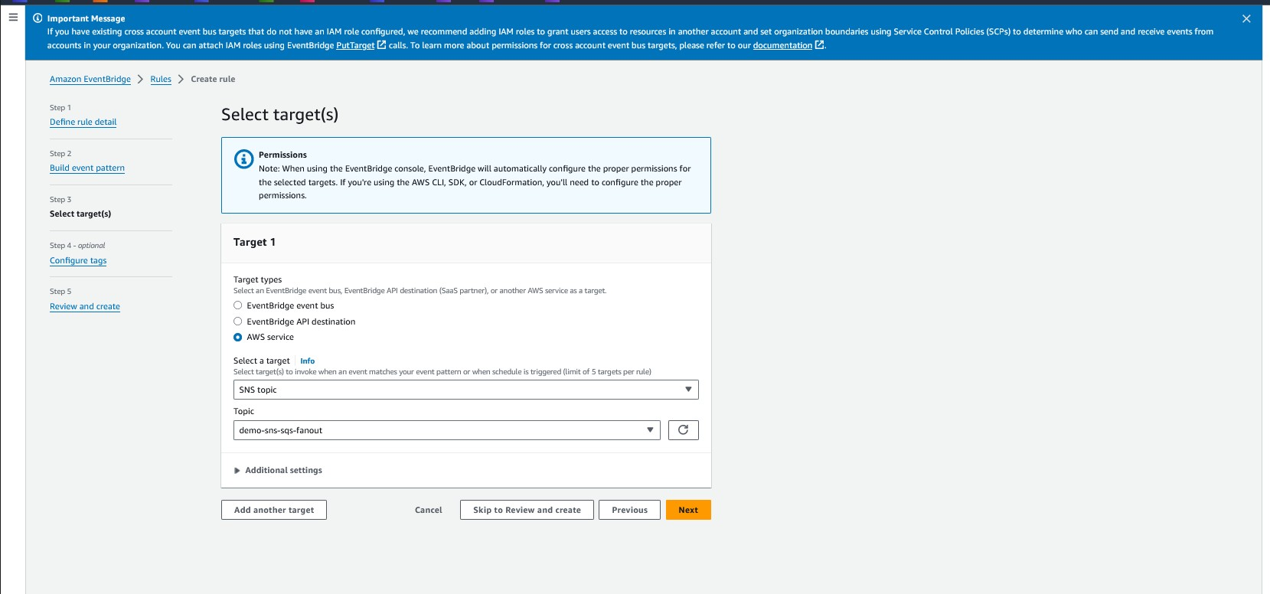

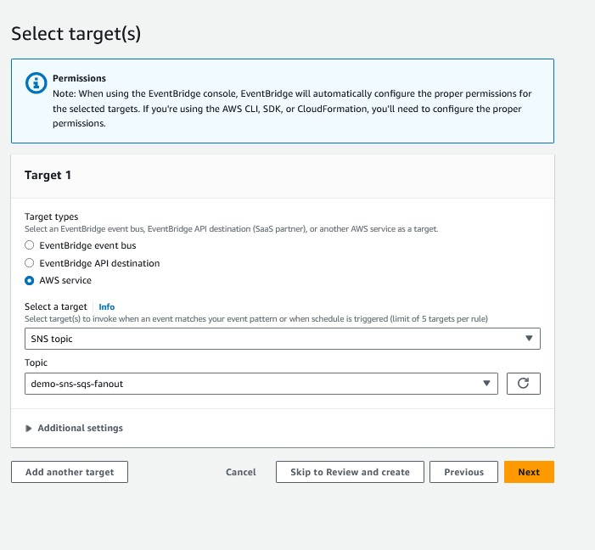

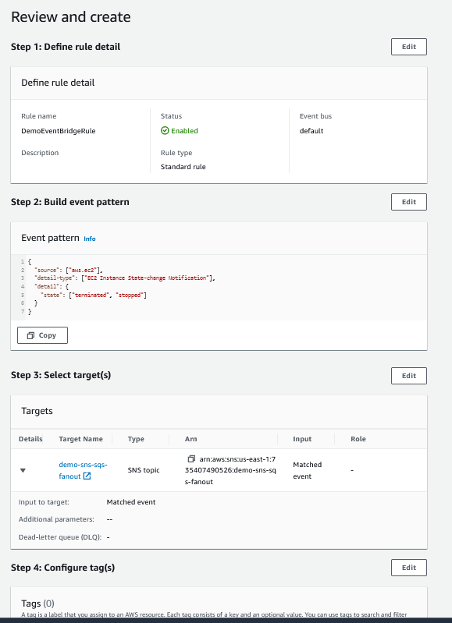

* **Event bridge created.**

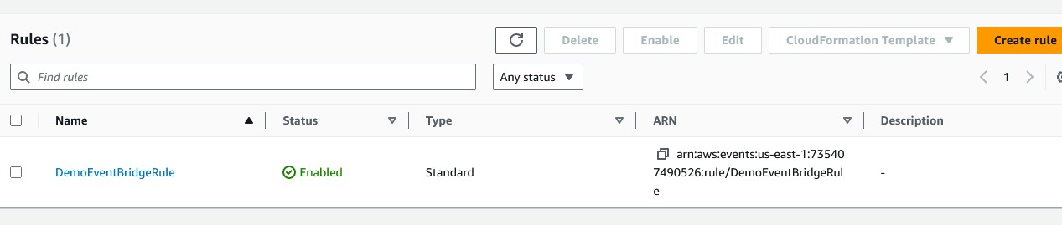

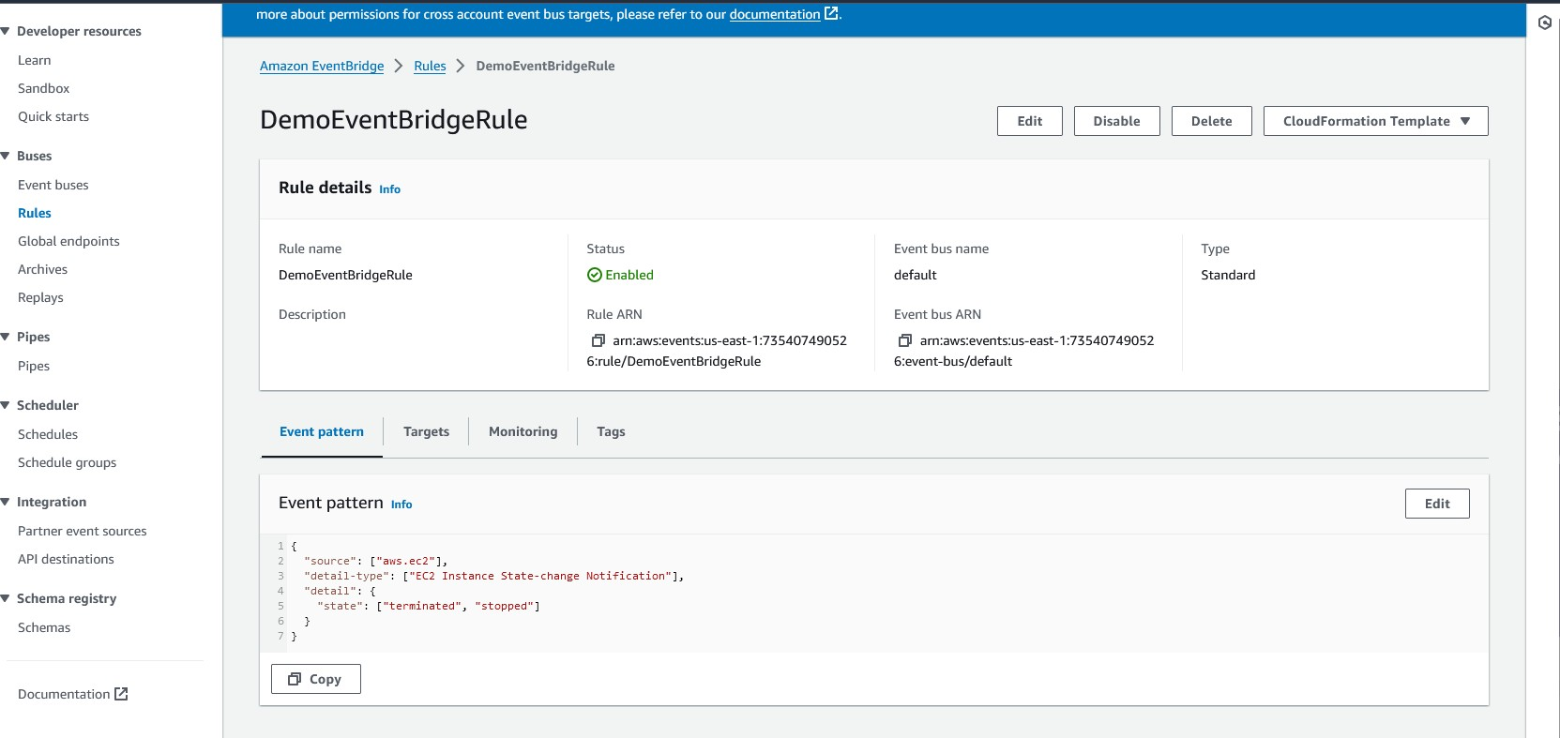

* **A schema was created by AWS, which can used by other application developers for reference within their code.**

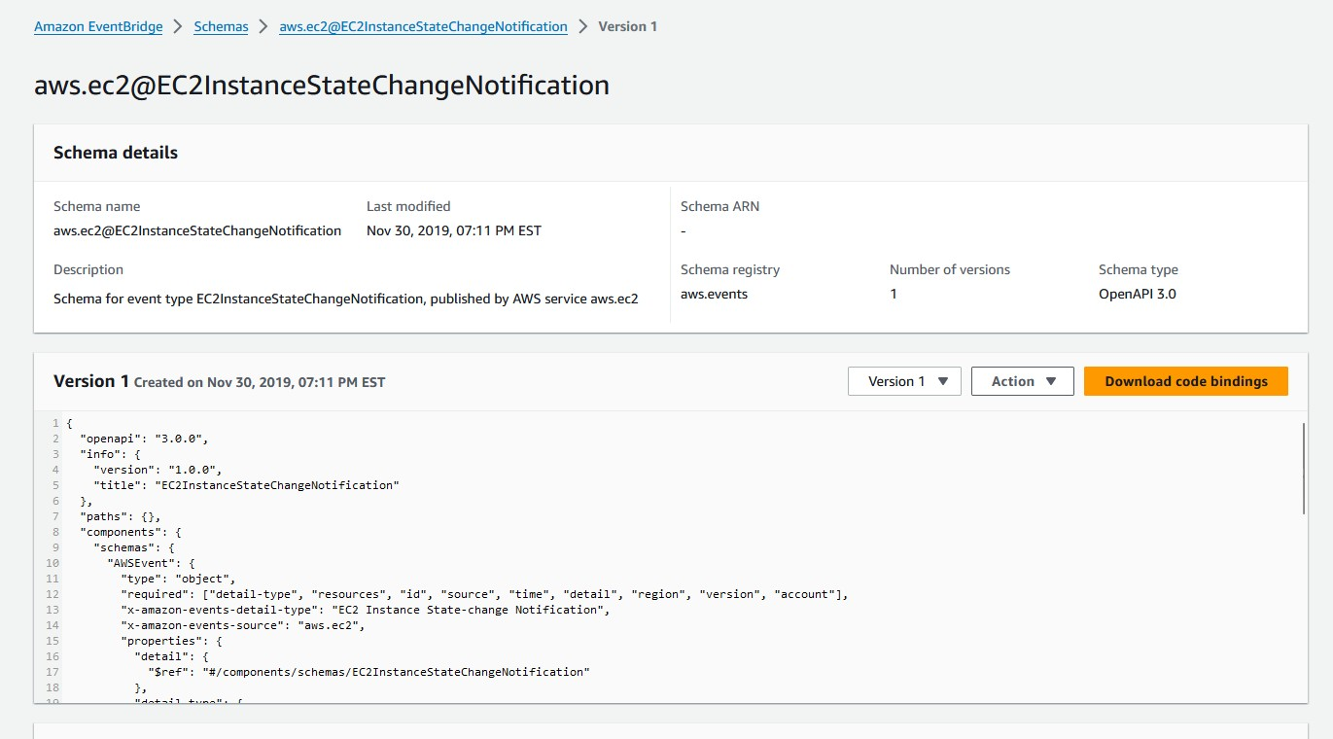

* **Notification received in email that an EC2 instance was stopped.**

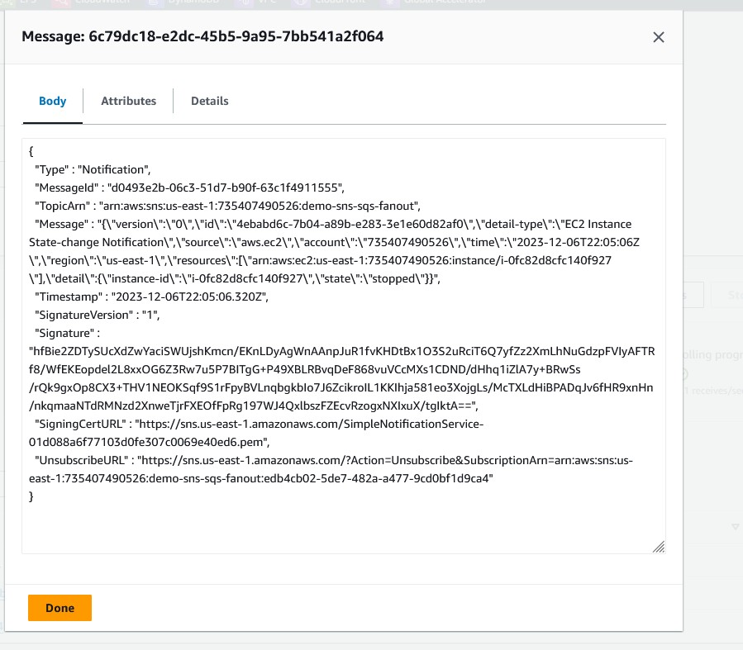

* **CloudTrail keeps a history of all activity within AWS account.**

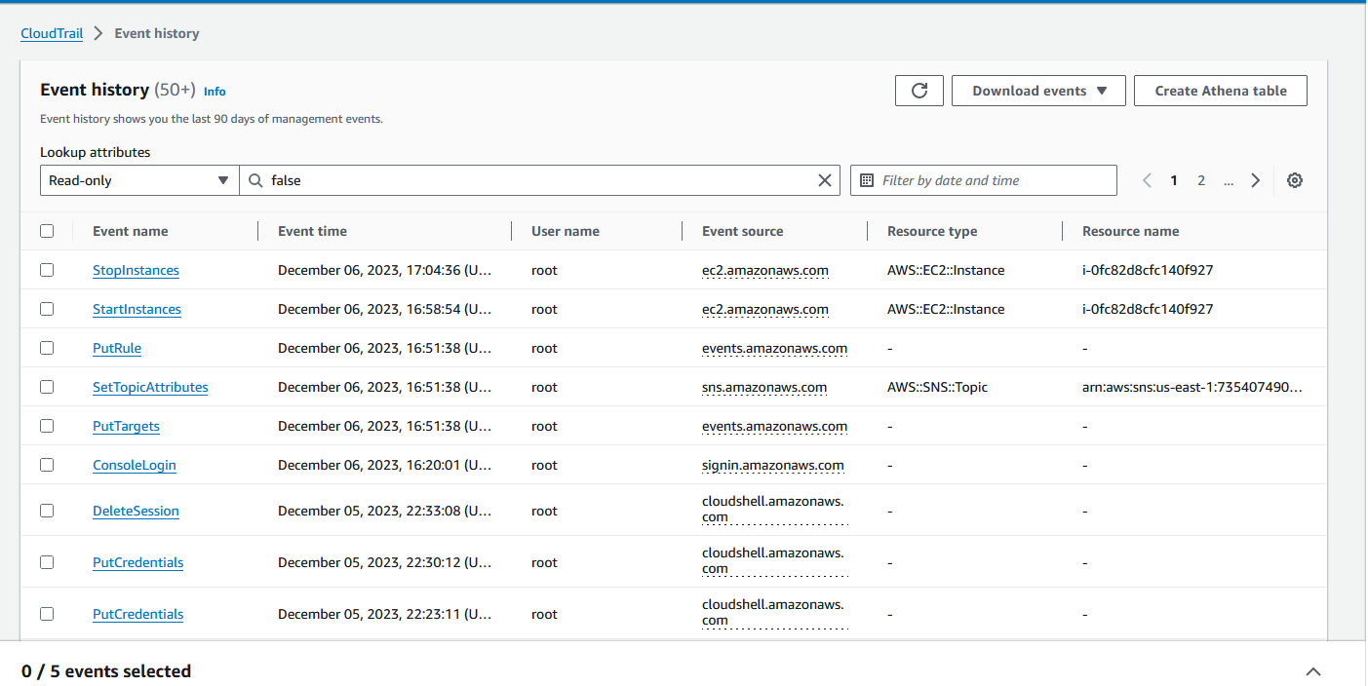

* **When an EC2 instance is stopped, a similar activity is recorded.**

